The following and attached information will be useful for your experimental planning, vessel scheduling, and image/data analysis. The IncuCyte system is located in the University of Colorado Cancer Center Cell Technologies Shared Resource in RC1 South, Room 5404B.

Any cells that come into the CTSR must be mycoplasma free, you will attach documentation to your request in i-labs that shows this. The CTSR has mycoplasma testing services available here: mycoplasma testing services, cost is currently $54 to $74, depending on membership in the Cancer Center, and results are available within 24 hours. Mycoplasma test results are good for three months and then after three months the cells need to be tested again. Here are two examples of mycoplasma test results:
Example 1 and Example 2

steps for making a reservation.

Login to account on i-labs: https://cu.corefacilities.org/account/login
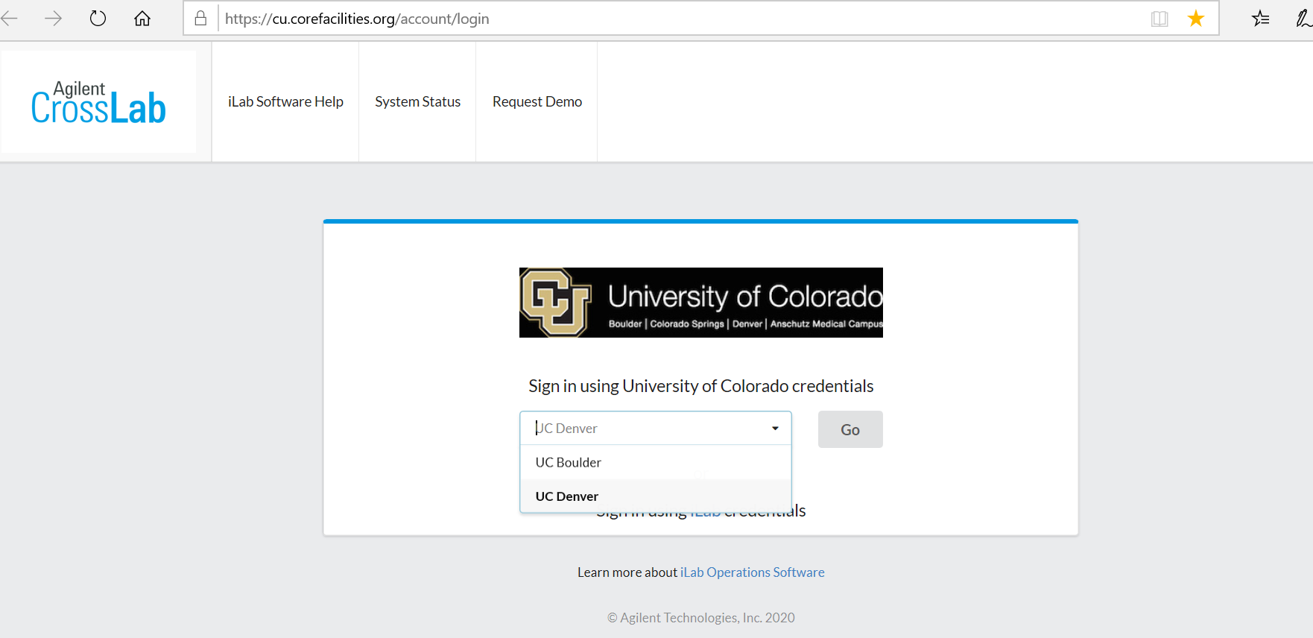
Click schedule equipment tab
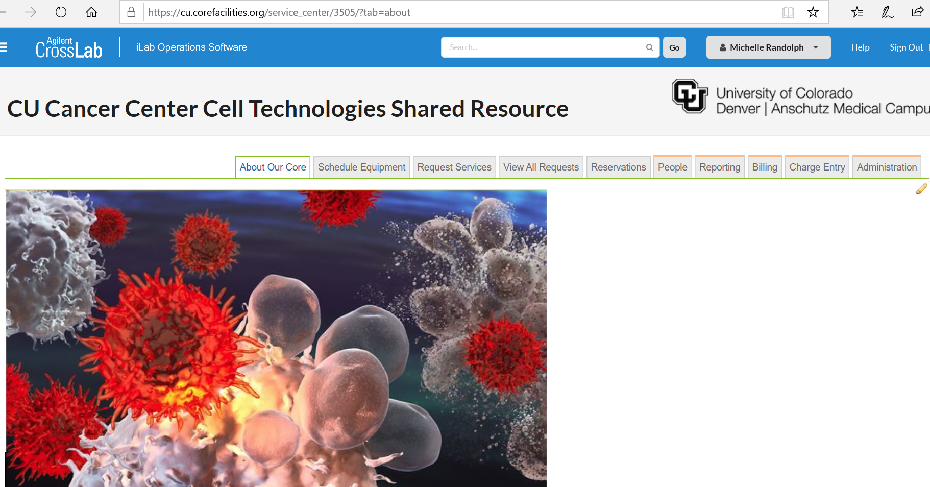
Click incucyte tab to see names of machines
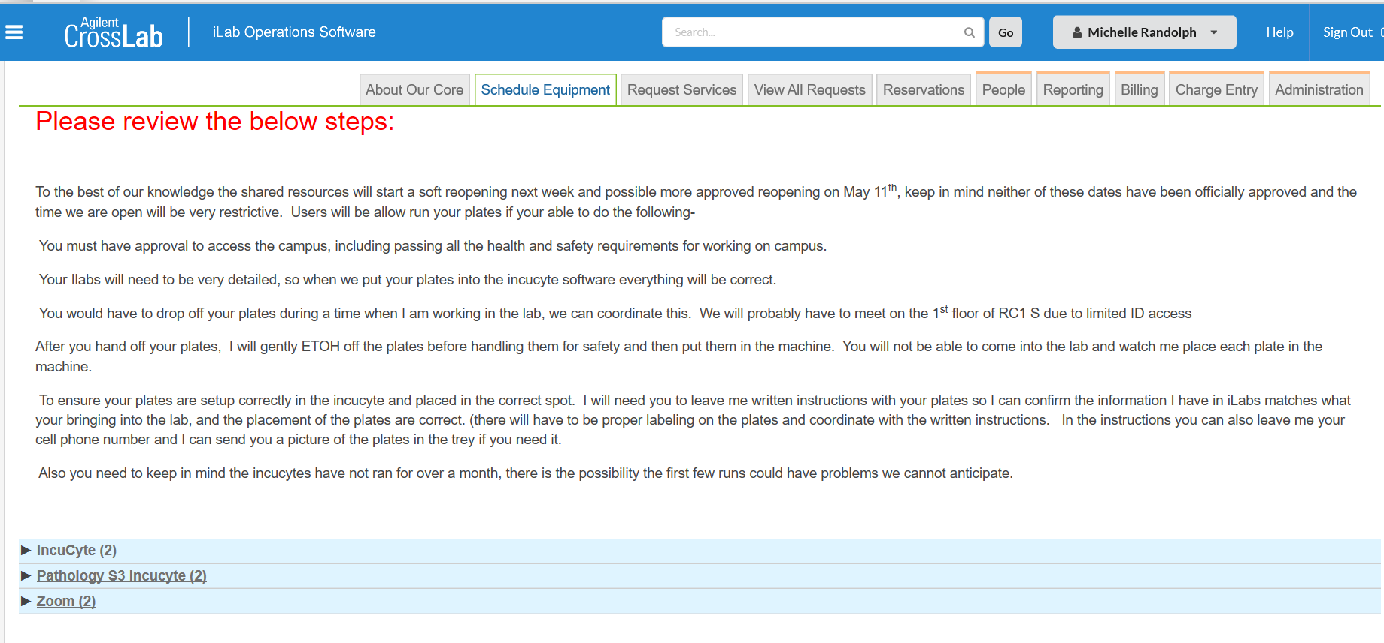
Click view schedule. Choose IncuCyte that has the desired module.
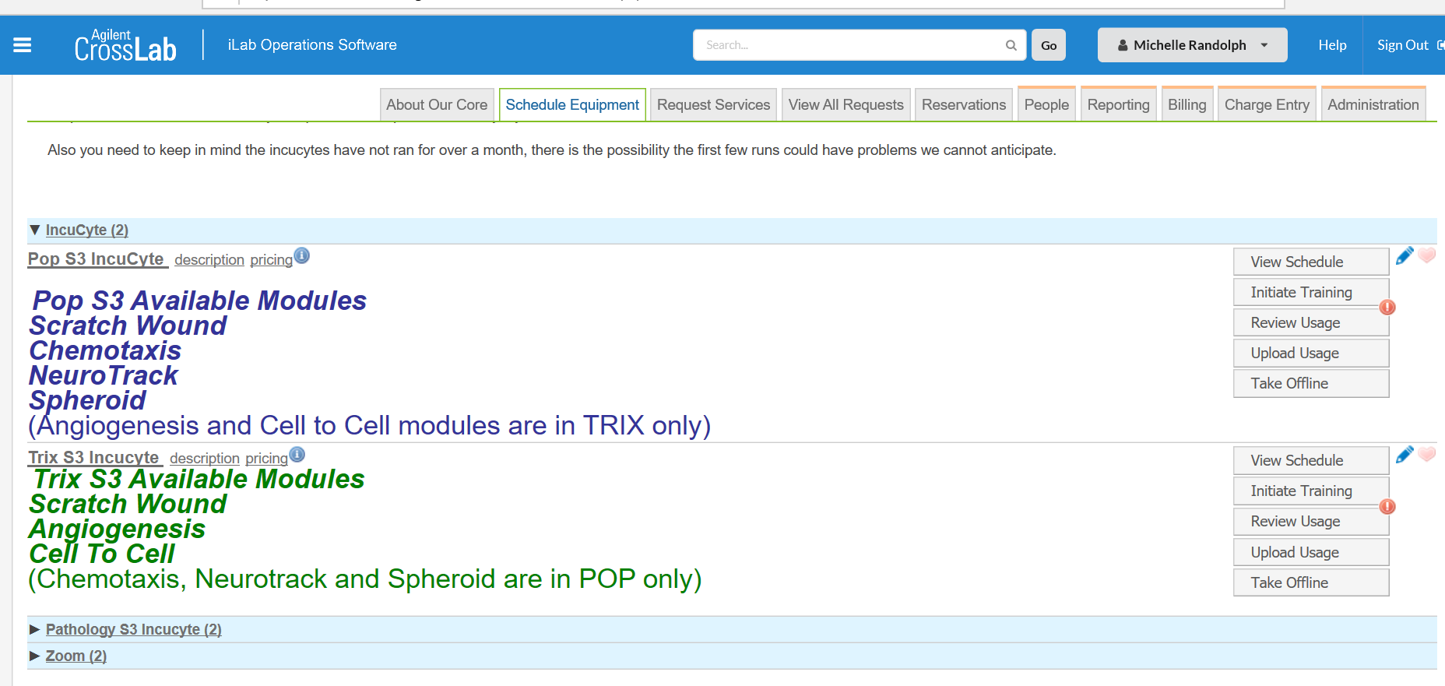
Navigate to date in calendar for reservation, double click
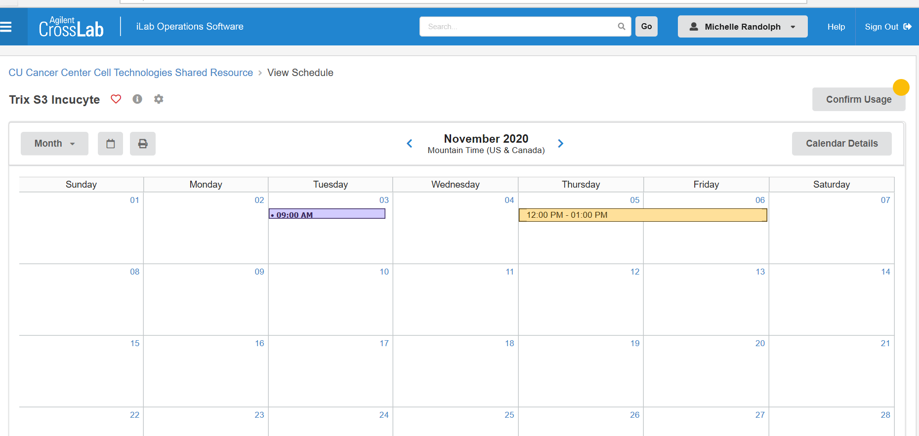
Create the reservation by completing the following fields:
Specify the required resource: choose the spot in machine, there are six
Times: use the pencil symbol to change start and stop times
Choose desired module
Choose scan length: repeated scan or scan on demand
Choose scan type
Choose scan settings: phase, green, red
Choose objective: 4X, 10X, or 20X
Number of scans per well
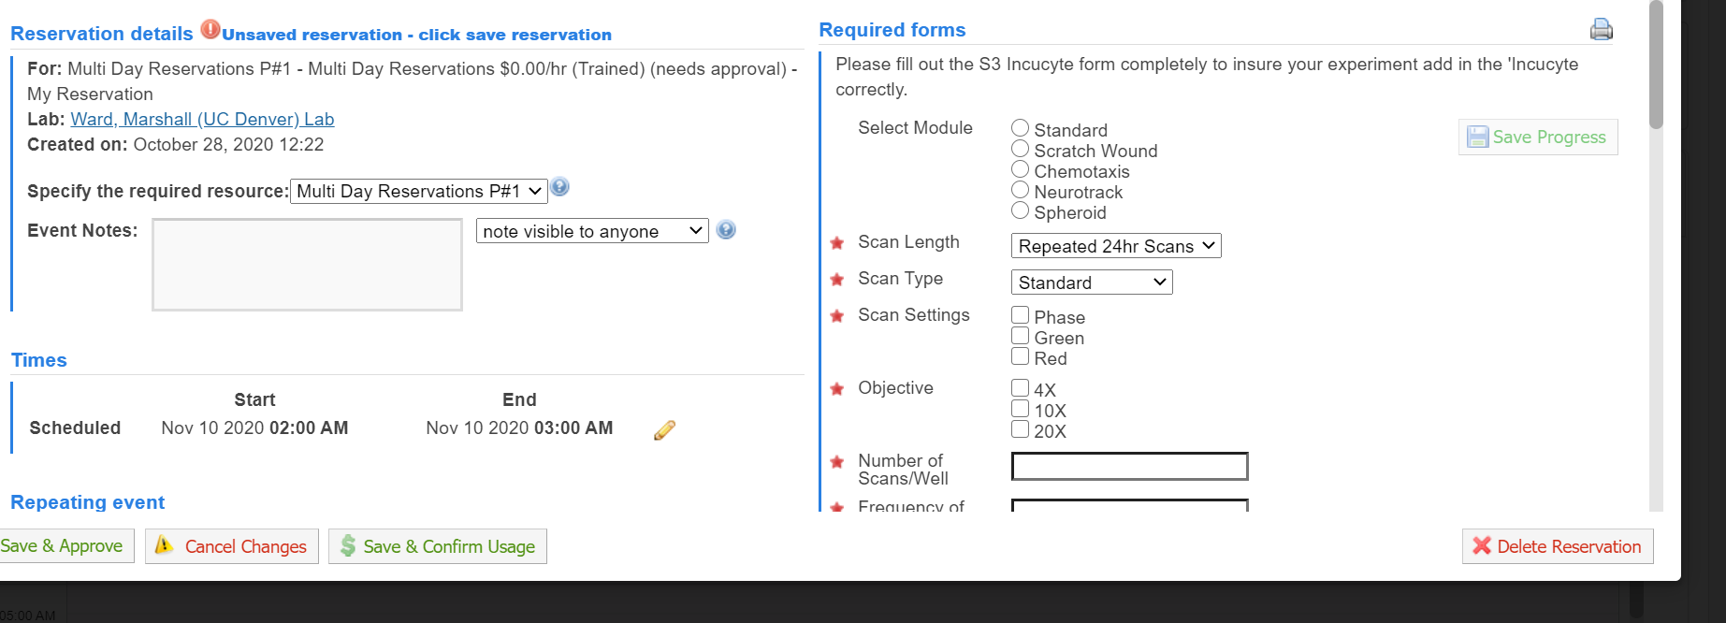

Complete the following fields:
Frequency of scans
Type of tissue culture plate
Manufacturer of plate
Catalog # of plate
Upload a diagram of your plate, showing which wells to scan
Type of cell line
PI name
Date
Passage number
Upload mycoplasma results
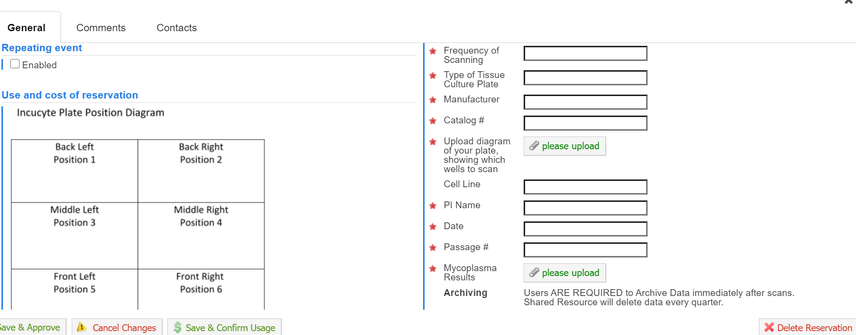

Complete the following fields:
Agree to terms of use
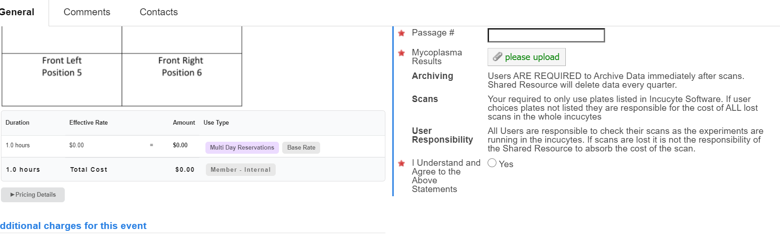

Complete information for speedtype. Click Save reservation button.
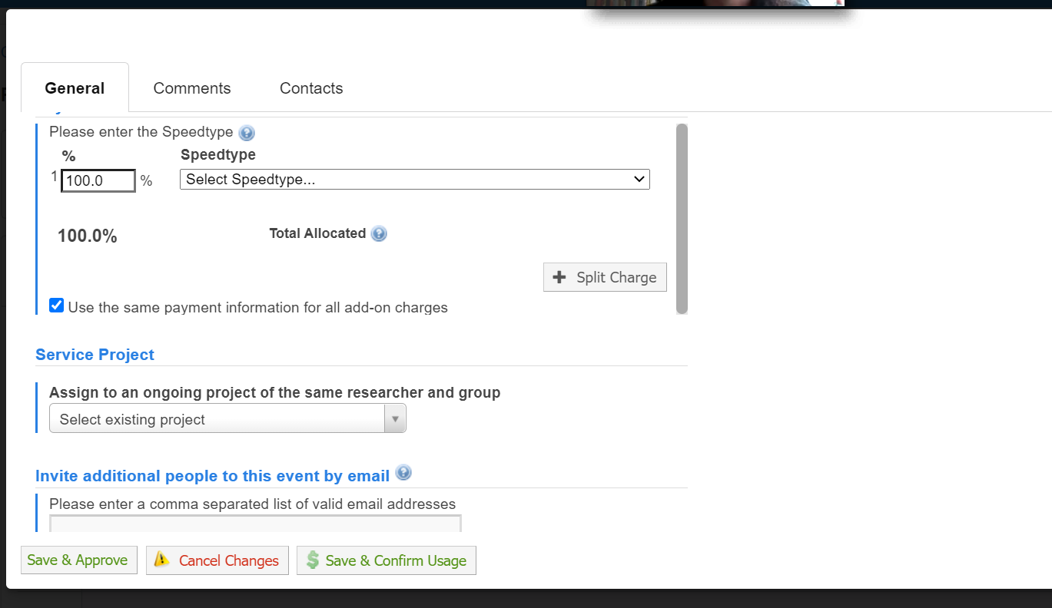

To get the software on your computer use this link. It will not work on Mac.
Here are the steps to download the software:
You can use this: https://www.essenbioscience.com/updates/Incucyte/Incucyte-2020B-GuiSetup/
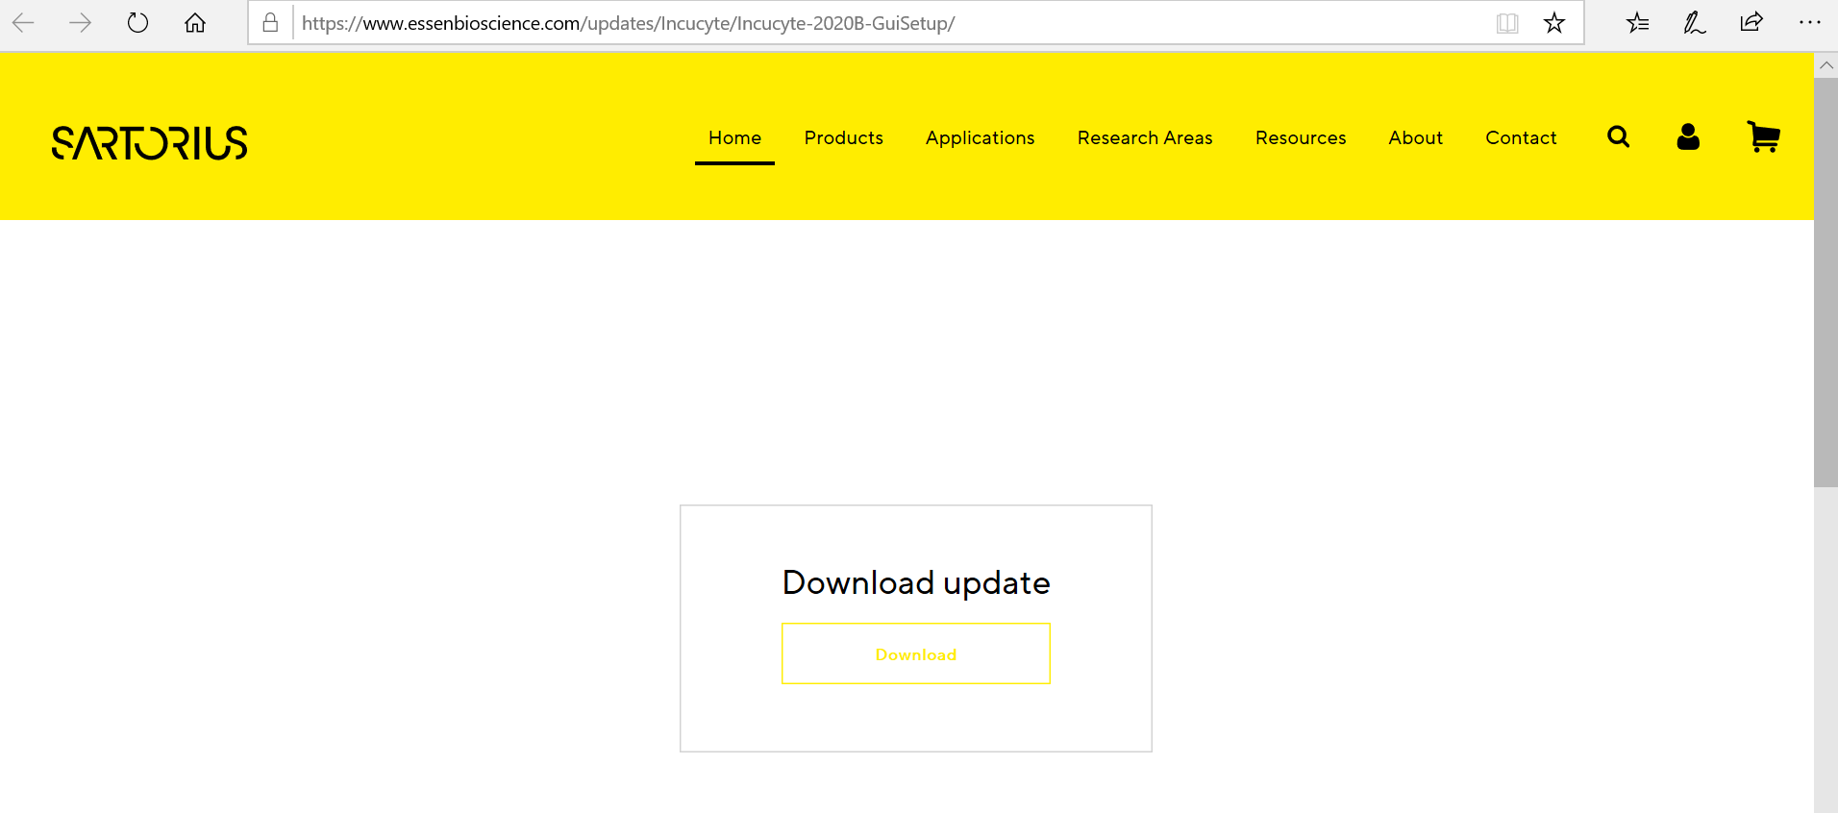
To login to the IncuCyte, open the program and choose Pop or Trix, enter username and password.
Then click connect.
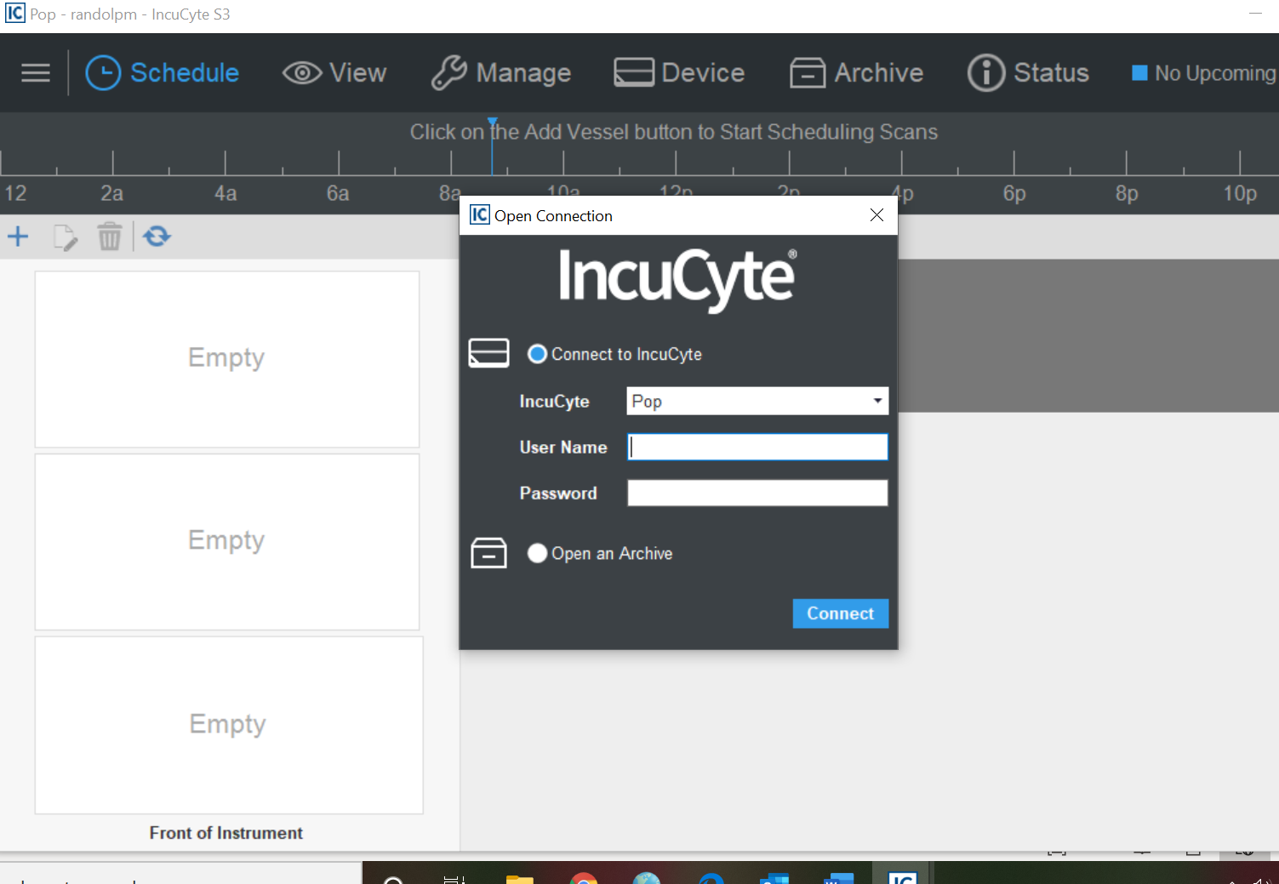
Click on the desired icons for scheduling, viewing, archiving, and status of scans.
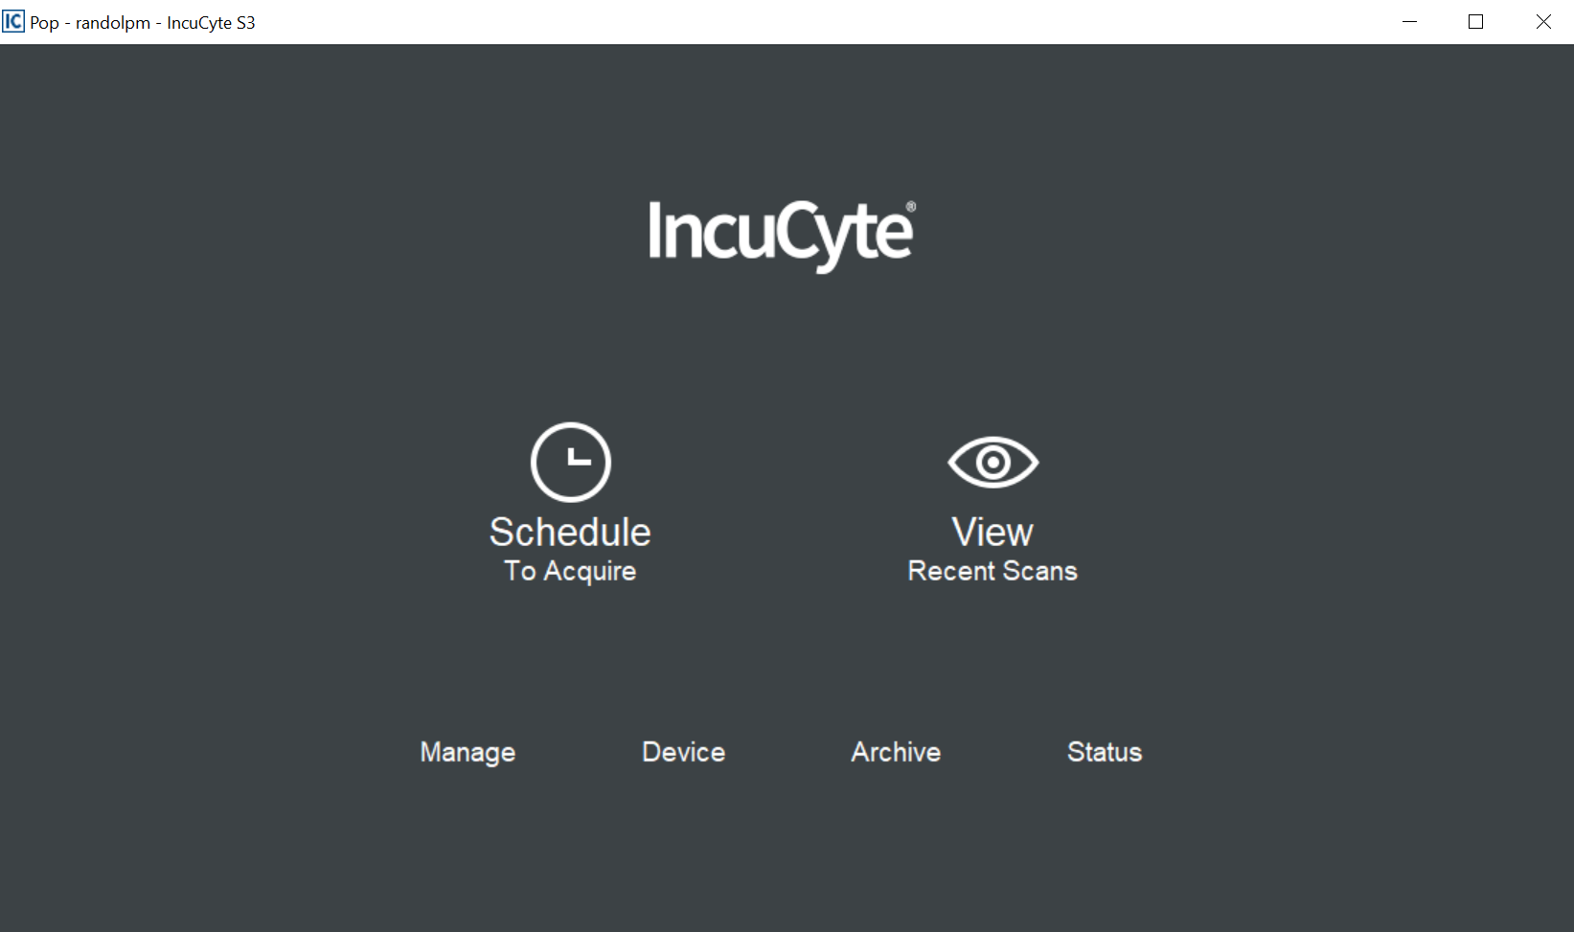

In order to create a processing definition, choose view scans, select your experiment and double click.
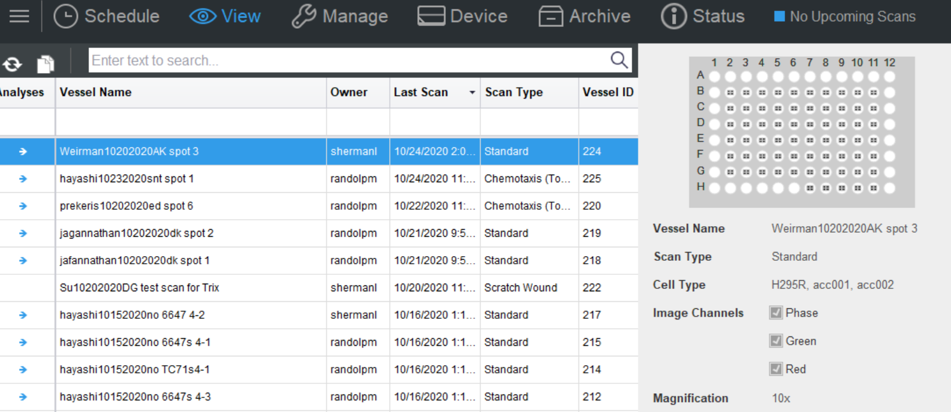

Choose the graph with gear icon.
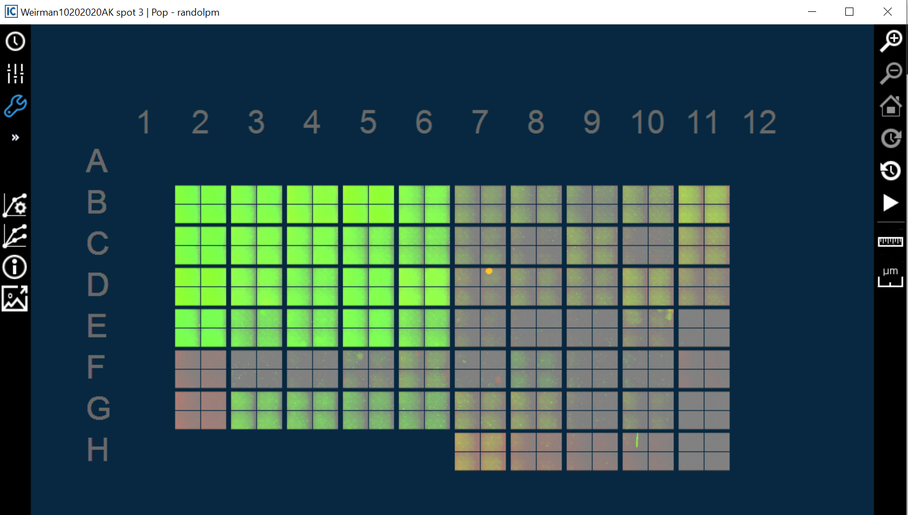

Create the analysis definition, use the next button to follow the process step by step.
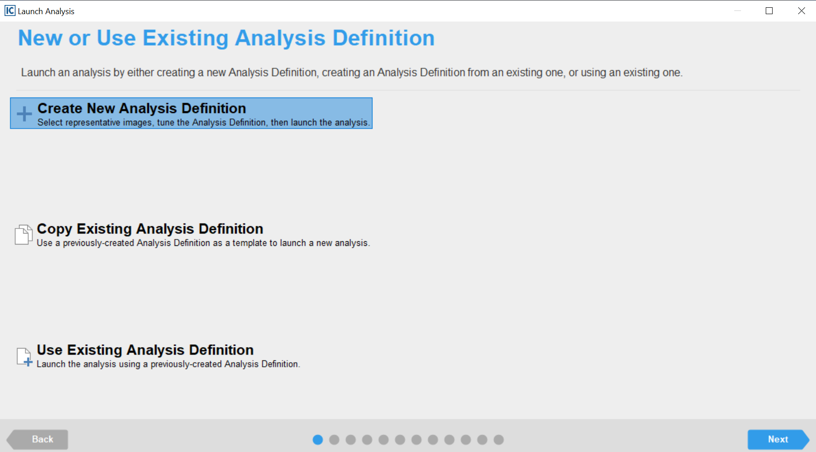

Once you have read the regulations for IncuCyte use, send the CTSR an email and let us know that, and the CTSR will create the account, and make the calendar in I-labs available to you. You will also need to send the CTSR a user name, which is the same as the PI that you work with, and a password of at least five characters.

Planning your experiments:
Links to Applications and Reagents for Planning IncuCyte experiments. Specific protocols available on our website.

If you’d like technical/experimental planning assistance, please send an e-mail to askascientist@sartorius.com and include the following information:

- What is the plate format/brand/cat no (ie 96-well Corning 3595) you'd like to use and how long will your experiment be?
- What cell type/s are you wanting to image?
- What is the biology you are trying to understand/quantify?
- Are there fluorescent probes you'd like to use? If so, what are the fluorophores?

