American Society for Quality
http://asq.org/learn-about-quality/root-cause-analysis/overview/overview.html
Definition: A root cause is a factor that caused a nonconformance and should be permanently eliminated through process improvement.
Root cause analysis is a collective term that describes a wide range of approaches, tools, and techniques used to uncover causes of problems.
“Five why’s”
Repeatedly ask ‘why?” to drill down to real reason for error
Some experienced practitioners say that you have reached the true root cause when the answer to your why question is a process, policy or a person. Often, these answers turn out to be the real root causes.
Example:
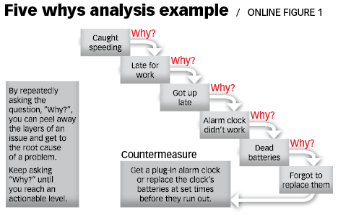

Mind Tools (https://www.mindtools.com/pages/article/newTMC_80.htm)
Root Cause Analysis (RCA) is a popular and often-used technique that helps people answer the question of why the problem occurred in the first place. It seeks to identify the origin of a problem using a specific set of steps, with associated tools, to find the primary cause of the problem, so that you can:
- Determine what happened.
- Determine why it happened.
- Figure out what to do to reduce the likelihood that it will happen again.
RCA assumes that systems and events are interrelated. An action in one area triggers an action in another, and another, and so on. By tracing back these actions, you can discover where the problem started and how it grew into the symptom you're now facing.
You'll usually find three basic types of causes:
- Physical causes – Tangible, material items failed in some way (for example, a car's brakes stopped working).
- Human causes – People did something wrong, or did not do something that was needed. Human causes typically lead to physical causes (for example, no one filled the brake fluid, which led to the brakes failing).
- Organizational causes – A system, process, or policy that people use to make decisions or do their work is faulty (for example, no one person was responsible for vehicle maintenance, and everyone assumed someone else had filled the brake fluid).
RCA looks at all three types of causes. It involves investigating the patterns of negative effects, finding hidden flaws in the system, and discovering specific actions that contributed to the problem. This often means that RCA reveals more than one root cause.
Step one: identify the problem (error, nonconformance, etc)
Step two: collect information
How long has error been happening?
What is the impact? (how many patients/studies affected)?
Involve as many people as necessary that who understand the situation/familiar with the problem
Step Three: Identify possible causal factors
Sequence of events that led to the error?
Conditions that existed to allow problem to occur?
Identify as many causes as possible, don’t stop at one or two
Tool: Fishbone diagram (cause and effect diagram) (http://asq.org/learn-about-quality/cause-analysis-tools/overview/fishbone.html)
Step Four: Identify the root cause
Why does it exist?
What is the real reason the problem occurred?
Step Five: Recommend and Implement Solutions
What can prevent error from occurring again?
How will solution be implemented?
Who will be responsible?
What are risks of implementing the solution?

Tools:
Fishbone Diagram
https://www.isixsigma.com/tools-templates/cause-effect/cause-and-effect-aka-fishbone-diagram/

CATWOE
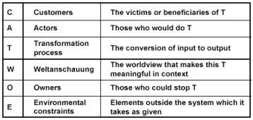
C- The customers of the system. In this context, customer means those who are on the receiving end of whatever it is that the system does. Is it clear from your definition who will gain or lose?
A- The actors, meaning those who would actually carry out the activities envisaged in the notional system being defined.
T- The transformation process. What does the system do to the inputs to convert them into the outputs.
W- The Weltanschauung (world view) that lies behind the root definition. Putting the system into its wider context can highlight the consequences of the overall system. For example, the system may be in place to assist in making the world environmentally safer, and the consequences of system failure could be significant pollution.
O- The owner(s) - i.e. those who have sufficient formal power over the system to stop it existing if they so wished (though they won't usually want to do this).
E- The environmental constraints. These include things such as ethical limits, regulations, financial constraints, resource limitations, limits set by terms of reference, and so on.

