Virtual Defense and Oral Exams

Tips, Tricks, & Resources

If you find yourself making the switch from a face-to-face graduate defense or oral exam to the virtual environment, it can be an adjustment! Start with these key tips, tricks, and resources both for graduate students and committee members.

PREP-WORK
COMMITTEE MEMBERS:
- Share this helpful guide with your students!
- Take time to become to become familiar with Zoom:
  - Sign in to ucdenver.zoom.us using your CU credentials.
  - Become familiar with Host functions, as you will be made Host during the private exam portion.
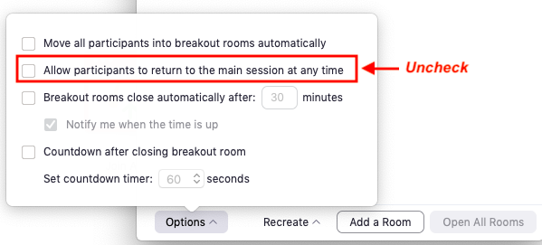
  - Practice with a colleague or family member using breakout rooms. A Breakout Room will be used as a “virtual hallway” for the student when the committee discusses privately.
    - Know how to create a breakout room, send a participant to the room, and adjust settings to only allow the student back to the main room when invited.
- Remind the student to take time to adjust Zoom settings and practice ahead of time.
- Exchange phone numbers with the student, in case you have technical difficulties during the defense/exam and need to communicate with one another.

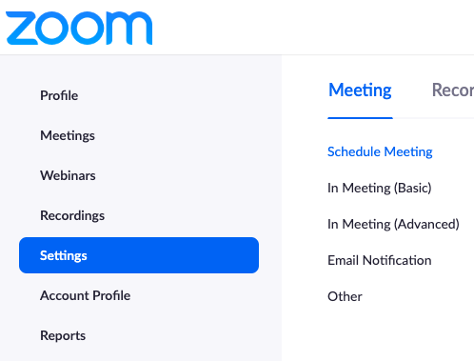
STUDENT:
- Sign in to ucdenver.zoom.us using your CU credentials
- Find your personal meeting room URL and send an invitation to your committee and others invited to the public presentation.
- View this Zoom Guide for basic functions
- Consider using these settings, to avoid distractions during your presentation or exam. These can be found in your Zoom account settings:
  - Mute participants upon entry
  - Turn off Chat function.
  - Turn off sound when participants join or leave
- Practice! Gather a few family members or friends on Zoom for a trial run.
  - Practice in the same environment you’ll be hosting the presentation and exam, to test for internet connection, sound quality/background noise, sharing your screen and presentation, and headphone use (if necessary).
  - Practice with the Managing Participants button, where you can mute or unmute participants, participants can raise hands, etc. (these skills will be useful during the Q&A portion of the presentation).
- Avoid using animations in your presentation, as it might appear glitchy to viewers.
- Exchange phone numbers with your committee, in case you have technical difficulties during the defense/exam and need to communicate with one another.

STARTING & RUNNING THE PUBLIC PRESENTATION
COMMITTEE MEMBERS:
- Consider asking the student to designate a committee member as a Co-Host (under Manage Participants) to help manage participant questions during the presentation or Q&A portion.
- Introduce the student, as you normally would in a face-to-face defense presentation.
- Let participants know that they have been muted, and that they may unmute and ask questions at the end of the presentation.
- Remember to mute yourself as well, to minimize distractions for the student.
- At the end of the public presentation and Q&A portion, reiterate to participants that the public portion has concluded and ask them to leave the meeting.

STUDENT:
- Log in to ucdenver.zoom.us and start your meeting early.
- Turn off all sound notifications for other computer applications (email, social media, texts, etc).
- Have a clock or timer visible. Time can go surprisingly fast during a virtual presentation!
- If you have a large group with many questions, you may choose to mute all participants upon entry (under Manage Participants > More).
- For questions at the end of the presentation, you can either invite participants to “raise their hand” and then call on them by unmuting their sound or invite participants to unmute themselves and ask questions.
  - The structure for taking questions is your choice, depending on the size of the group and format you prefer.

DURING THE PRIVATE DEFENSE or EXAM
COMMITTEE MEMBERS:
- Choose who will become the Host. Choose whoever is most comfortable using Zoom. Ask the student to use the Manage Participants button to make the chosen committee member the new Host.
Host will create a Breakout Room, and add the student to the room when the committee needs to discuss in private.
  - Adjust Breakout Room settings to only allow the student back to the room when invited.
- Have a clock or timer visible. Time can go surprisingly fast during virtual meetings!

STUDENTS:
- Use the Manage Participants button to make the chosen committee member the Host.
- Have blank paper and a pen next with you, in case you need to draw/write and show the committee during the exam. You could also try the Whiteboard function in Zoom (select this option under Share Screen).
- Have other devices (phone, tablet, etc) with you, in case you need to use it as a second camera to demonstrate drawings/writing. (Remember to mute these devices!)
  - Download the Zoom app on your phone and/or tablet beforehand
- At a given time, the committee will need to discuss privately without you. Join the breakout room created, and wait to be invited back to the main room.

FINISHING TOUCHES
SIGNATURES & FORMS:
The Graduate School prefers electronic or digital signatures, if possible.
If email approval is necessary, please follow the following format ONLY:
- The chair, mentor or other leader starts an email thread including all necessary approvers, plus Graduate School recipients.
- The subject should be clear & complete (e.g. "Email Approval of XXX for <Student's Last Name>). We will need to be able to search, catalog and archive these messages, and vague subjects make that impossible.
- Each approver uses REPLY ALL to the thread with their decision so that everyone involved can see everyone's decision, and all decisions are linked together in a single thread for archiving.
- The Graduate School may seek ink signatures on critical forms (such as Exam Reports or Thesis Approvals). Please check with your school/college representative.

CELEBRATE!!
- Take a Picture! This is a unique situation, and you have a good story to tell. Take a screenshot with your committee, or a selfie!
- It may not be the defense or exam that you imagined, but don’t forget to celebrate in your own way. Dance, call a friend, celebrate you!

TECH SUPPORT
If you find yourself needing technical support, contact one of these service desks:

OIT Service Desk
Phone: (303) 724-4357
Email: oit-servicedesk@ucdenver.edu
Website: https://ucdenver.edu/oit

Zoom Tech Support (24/7 Support)
Phone: 1-888-799-9666 (ext. 2)
Support & Tutorials: Zoom Help Center

SECURITY CONSIDERATIONS
“Zoombombing” is a form of trolling in which a participant uses Zoom’s screensharing feature to interrupt and disrupt meetings and classes. Consider the following advice on guarding against this:
- Don’t post Zoom URLs in public spaces. Not twitter, not forums, not open. Share only with meeting attendees.
- Use Advanced Settings to ensure that Who can share? Is set to Host Only.
- Don’t use a Personal Meeting ID for Zoom meetings. These are easy to find and hack. The default Zoom Meeting IDs are randomized, and difficult to find and hack.
- Use Require Meeting Password to be extra careful. Include the password with the Zoom URL when sending invitations.
- Use the Waiting Room feature to control who enters your Zoom.
- Use Advanced Settings to disable file transfer.
- Consider locking the meeting after it starts. Look under Manage Participants at the bottom of the Zoom window. You can lock the door here under More.

