Digital Accessibility Checklist for New Documents

Word Documents

Organize Content:
- Use heading styles (H1, H2, H3, etc.) for structure.
- Avoid using blank lines for spacing; use paragraph spacing settings.
- Use numbering and bullet tools to create lists.
- Ensure document is tagged for accessibility.
- Navigate document using arrow keys, Tab and Enter to verify keyboard navigation.
- Check page order.
- Add document title (Scroll down from File > Properties > Click on Summary tab > Add document title).
- Set the primary language and indicate any changes within document.

Optimize Writing:
- Simplify content, focus on clear, concise, and audience-friendly language.

Text and Fonts:
- Use a minimum of 12-point font.
- Use sans serif fonts (e.g., Arial, Helvetica Neue).
- Avoid overly decorative styles.

Tables:
- Use tables for data, not layout.
- Use simple table structures.
- Specify header rows and avoid merged or split cells.

Images and Graphics:
- Add alternative text to all images and graphics.
- Mark decorative images as decorative.

Hyperlinks:
- Use descriptive link text (e.g., "Visit our website" instead of "Click here").
- Only underline link text.

Color and Contrast
- Check color contrast of text and graphics with a color contrast checker.
- Text Contrast- 4.5:1(normal text) and 3:1 large text.
- Use color along with other visual cues to convey information.
- Visit the CU Denver Brand Book to check contrast pairings.

- Or use these recommended color pairings
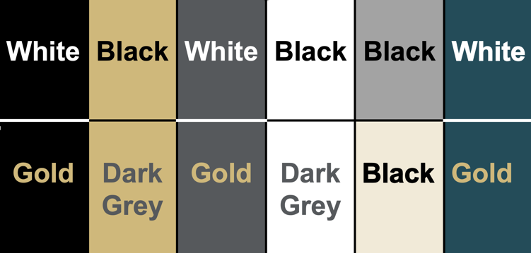

Multimedia
- Provide captions for all video content (Use Panopto).
- Include audio descriptions for pre-recorded videos.
- Offer transcripts for audio-only content.

Accessibility Checker
- Use built-in Accessibility Checker to identify and fix issues.
- Always do a manual check.

PDF Conversion
- Always use Save As and set to a PDF, do not print to PDF.
- Check accessibility in Adobe Acrobat Pro.

PowerPoint Presentations

Slide Design:
- Use built-in slide layouts for consistent reading order.
- Only add six bullet points or less to a slide.
- Ensure every slide has a unique and descriptive title.
- Double check reading order.
- Navigate document using arrow keys, Tab and Enter to verify keyboard navigation.
- Set the primary language and indicate any changes within.

Optimize Writing:
- Simplify content, focus on clear, concise, and audience-friendly language.

Text and Fonts:
- Use sans-serif fonts (e.g., Arial, Helvetica Neue).
- Titles: 28pt+.
- Headings: 28pt+.
- Body text: minimum of 28 points

Tables:
- Use tables for data, not layout.
- Use simple table structures.
- Specify header rows and avoid merged or split cells.

Images and Graphics:
- Add alt text to all images, charts, and graphics.
- Mark decorative images as decorative.

Hyperlinks:
- Use descriptive link text (e.g., "Visit our website" instead of "Click here").
- Only underline link text.

Color Contrast:
- Ensure sufficient contrast of text, background, and graphics with a color contrast checker.
- Text Contrast- 4.5:1(normal text) and 3:1 large text.
- Use color along with other visual cues to convey information.
- Visit the CU Denver Brand Book to check contrast pairings.
- Or use these recommended color pairings

- Use Accessible Gold
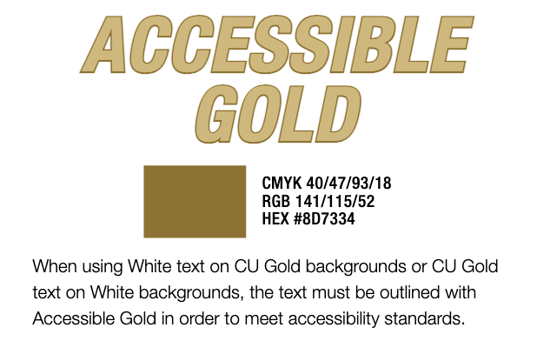

Multimedia:
- Provide captions for all video content (Use Panopto).
- Include audio descriptions for pre-recorded videos.
- Include speaker notes to provide extra context for screen readers.
- Offer transcripts for audio-only content.

Accessibility Checker:
- Use built in Accessibility Checker to address any issues.
- Always do a manual check.

PDF Conversion:
- Save as PDF, ensure document structure is tagged for accessibility.
- Check accessibility in Adobe Acrobat Pro.

PDFs

Document Structure and Properties:
- Use a clear and logical structure with headings (H1, H2, H3, etc).
- Ensure the document is tagged properly.
- Navigate document using arrow keys, Tab and Enter to verify keyboard navigation.
- Verify the reading order.
- Set the primary language and indicate any changes within.
- Set the document title (Under Document Properties > Description &
Initial View > Show > Document Title

Text and Fonts:
- Use readable fonts and avoid overly decorative styles.

Tables:
- Use tables for data, not layout.
- Use simple table structures.
- Specify header rows and avoid merged or split cells.

Images and Graphics:
- Add alt text to images, charts, and other graphics.
- Mark decorative images as decorative.

Hyperlinks:
- Use descriptive link text. (e.g., "Visit our website" instead of "Click here").
- Only underline link text.

Color and Contrast:
- Ensure sufficient contrast of text, background, and graphics with a color contrast checker.
- Text Contrast- 4.5:1(normal text) and 3:1 large text.
- Use color along with other visual cues to convey information.
- Visit the CU Denver Brand Book to check contrast pairings.
- Or use these color pairings.

Multimedia:
- Provide captions for all video content (Use Panopto).
- Include audio descriptions for pre-recorded videos.
- Offer transcripts for audio-only content.

Accessibility Checker:
- Use Anthology Ally (built into Canvas) to identify accessibility issues.
- Use Adobe Acrobat's Accessibility Checker to identify and fix issues.

Emails

Optimize Writing:
- Write for your audience.
- Use active voice.
- Use full terms on first reference and introduce the acronym in parentheses for future reference (e.g., The Division for Teaching Innovation and Program Strategy (TIPS)).
- Follow a consistent capitalization scheme.
- Use inclusive language.
- Spell out numbers one through nine. Use numerals for 10 and above.
- Follow common style guidelines for capitalization, hyphenation, and punctuation.
- Capitalize the first word of every bullet. Use periods only when a point is a complete sentence.

Text and Fonts:
- Use sans serif fonts (e.g., Arial, Calibri, Helvetica, Tahoma).
- Keep text at a reasonable size, 11 or 12pt.
- Use emojis at the end of message instead of in between words and never to replace words.
- Avoid emoticons they lose their meaning when read with assistive technology.
- Use black text on a white background.
- Use text labels (eg., labeled in dark red) or patterns in addition to color, especially for important information.
- Use actual text when adding a signature and add alt text for the CU Denver logo.

Organize Content:
- Use clear and descriptive subject lines that accurately reflect email content.
- Align text to the left instead of centered or justified.
- Break up text into short paragraphs.
- Structure content logically using headings and subheadings.
- Navigate document using arrow keys, Tab and Enter to verify keyboard navigation.

Images and Media:
- Provide alt text for images.
- Avoid images of text, include text directly in the email.
- Include captions for multimedia and transcripts for recorded lectures or event recordings (use Panopto).
- Add important information (date, time, location) from event posters directly into email.

Hyperlinks and Attachments
- Use descriptive link text (e.g., "Visit our website" instead of "Click here").
- Only underline link text.
- Before attaching a document, determine if the information can be included directly to the body of the email. If not, make sure the document is accessible.

Tables:
- Use tables for data, not layout.
- Use simple table structures.
- Specify header rows and avoid merged or split cells.

Accessibility Checker:
- Use the accessibility checker in Outlook.

Always review documents after using any accessibility checker, no tool is perfect.

