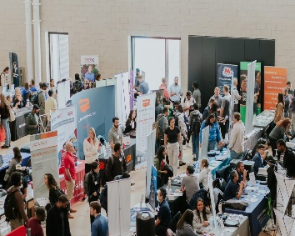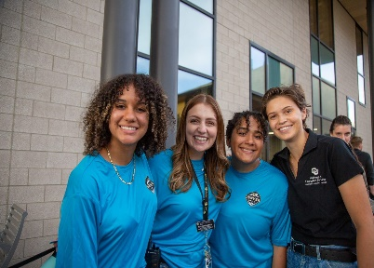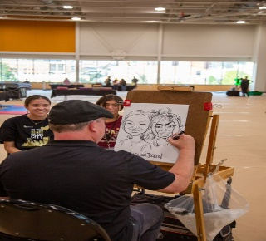
Wellness & Recreation
By the Numbers
General building Use and Program Use 7/1/2022 - 4/15/2023
- Distinct member entrance – 5163 (50.125% of eligible students entered facility)
- Participations in building use excluding event usage 130,241
- Event Participants based on estimated attendance from groups 21,000
- 1678 in-person Group Fitness participations
- 264 remote Group Fitness participations
- 151 Personal Training participations
- 1659 Climbing Wall Participations
- 87 trip Participants
- 1923 Pool participations
- 61 CPR certifications over 9 classes
- 250 Sport Club members
- 50 Sport Club events
- 4 National Tournament teams 1 National Champion (Swimming)
- 116 IM sports Participants
- 593 students were reached through our financial wellness program
- 72 total individual coaching sessions via Zoom and in-person
- 275 students attended Financial Wellness workshops
- 121 Loving Lynx applications received
- 202 Single Stop Screenings
Numbers Can’t Measure
- 28 cross campus collaborations
- Visited 15 FYE courses and 5 business classes
- Presented 6 Financial workshops
- Presented 7 Mental Health first aid classes
- 1 position grant funded
- 2 grants pending for Food Pantry and Financial Wellness
- Operate the on campus Food Pantry
- Largest Student employer on campus

