Conflict Mapping – 4 mapping tools

Benefits:
- See the bigger picture of the situation
- Gain insight into underlying causes so you aren’t just addressing the symptoms
- See additional perspectives
When do you conflict map?
- When you feel stuck
- When you can’t see a clear way forward
- When you don’t understand why the conflict exists in the first place
Who uses conflict mapping?
- Anyone and everyone
- On your own
- With your manager/supervisor or direct report
- With the person you are in conflict with

Relationship
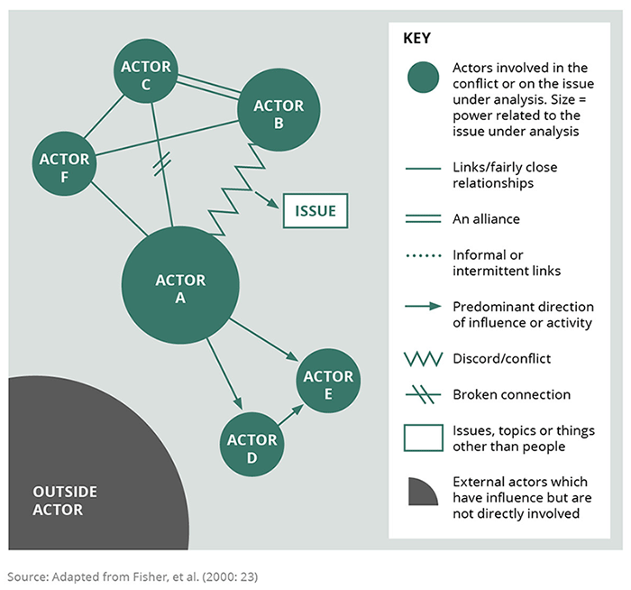
The Onion
Positions: What you say you want.
Interests: Why you want your position
Needs: The needs underlying your positions and interests
Party B Positions

Party A Positions

Party A Interests

Positions
Party B Interests

Interests

Needs

Party B Needs

Party A Needs

Timeline

Core Issue 1
Core issue 2
Cause 1
Cause 2
Cause 3
Cause 4
Cause 5
Effect 1
Effect 5
Effect 3
Effect 6
Effect 4
Effect 2
Causes
Effects
Core Issue

